Georgia Fire Service
Area 6 Mutual Aid Plan

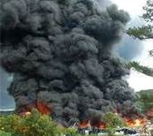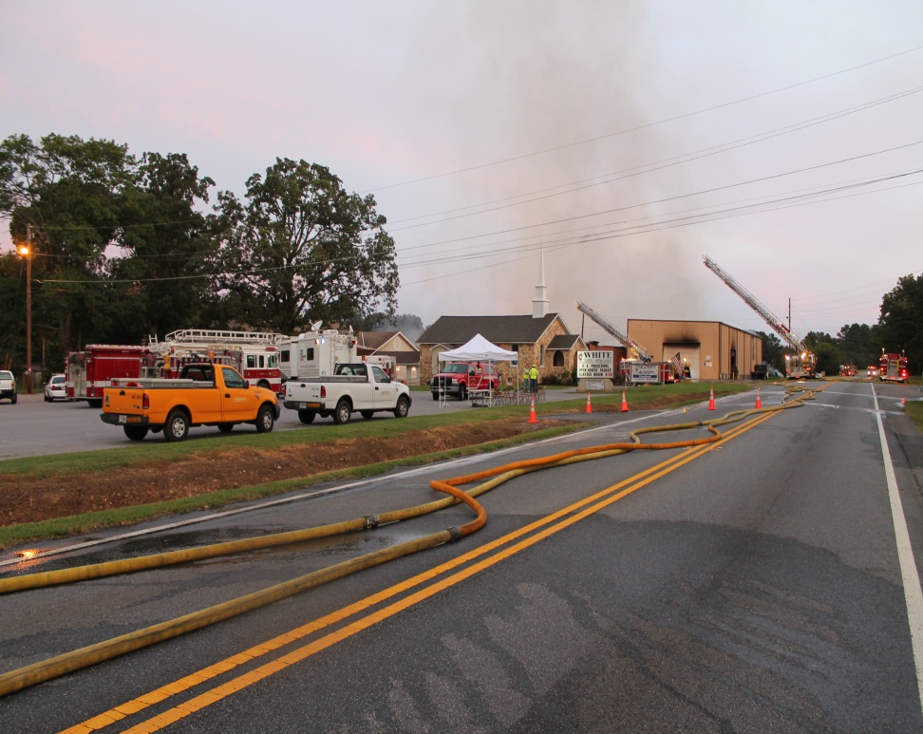

Purpose:
When the Northwest Georgia Fire Chiefs Association was formed in 2009, one of the main concerns of the membership was Mutual Aid, specifically knowing where to get resources, in a timely and safe manner from in the area, and a reliable procedure to request them. Since that time much research has been done by the executive board of the NwGFCA on how to address this issue. It was voted in the original bylaws of the association that the 1st VP would also serve as Area Mutual Aid Coordinator and the 2nd VP would serve in their absence.
In 2010 Battalion Chief Doug Flurry was able to get the members access to the GEMA/Ga. Tech data base created some years earlier to better have an idea what resources were located where in their area. The problem identified with that was that it was outdated and getting all of the departments to participate in updating it.
In 2011 and 2012 the Northwest Georgia area was hit by a number of disasters and large commercial fires. The membership of the NwGFCA voted to move forward with the MABAS System in our area in 2011. Later it was determined that the GAFC had entered into a contract with the IAFC to use a new computerized Mutual Aid Net system. The GAFC also entered into a contract to rewrite the State Fire Rescue Response Plan formerly written by GMAG.
In 2012 NwGFCA President Dwayne Jamison contracted with Ret. Chief Phil Chovan as a consultant to assist with writing a mutual aid plan for Area 6 (Northwest Ga.) that would fit into any other proposed mutual aid plan and would address the needs of departments in the area. The plan would also take into consideration lessons learned from recent and past mutual aid incidents.
This document is meant to assist the fire officers in Northwest Georgia when faced with a disaster or when local resources are overwhelmed or stretched thin. The intent of this document is not to create a new system, but to complement existing and future mutual aid systems, improve communications, coordination, and assure the safety and accountability of responders. The main purpose is to assure that we are able to assist one another in the area and move resources when and where they are needed in an efficient, effective, and timely fashion. This document should be reviewed annually and validated quarterly.

Scope:
This plan is intended to cover all major Mutual Aid requests for fire service resources in Northwest Georgia (Area 6). This covers the geographical area identified by the Georgia Association of Fire Chiefs, Georgia State Firefighters Association, GMAG, and Georgia Emergency Management Agency as Area 6 in the Northwestern corner of the state of Georgia, and all departments within that identified area.
This plan does not address the way that day to day Mutual and Automatic Aid responses and requests are handled. It does not address political and liability issues between agencies and municipalities, nor is it intended to address cost recovery issues.
This plan simply addresses how to effectively and efficiently help each other with needed fire service resources in times of disasters, major fires, Haz Mat incidents, technical rescues, or other incidents that overwhelm local resources.
The plan is intended to assist all fire departments in Northwest Georgia (Area 6). Membership to any organization or group is not a condition of receiving assistance or participation in this plan. If you have resources available and can contribute to your fellow firefighters in their time of need, they will certainly appreciate the assistance.

Definitions:
MAC 6 – Area 6 Mutual Aid Coordinator – Coordinates and tracks fire – rescue mutual aid resources within Area 6. The Northwest Georgia Fire Chiefs Association (NwGFCA) 1st Vice President shall act as the lead MAC 6 for the area. The NwGFCA 2nd Vice President shall serve as a MAC 6 and shall represent the 1st Vice President in their absence.
Liaison – person responsible for communication and coordination between two or more groups or agencies.
Type 5 Incident – Initial Attack – Usually handled by local resources – 1st Alarm
Type 4 Incident – Reinforced attack - Local resources can handle, along with additional mutual/automatic aid assistance from neighboring agencies.
Type 3 Incident – Extended Attack – Local resources exhausted, neighboring agencies involved, and outside agencies are needed to assist.
Type 2 Incident – Major incident – Local and regional resources are exhausted and state resources are needed to support the incident.
Type 1 Incident – Major Disaster – Local, regional, and state resources are exceeded and federal assistance is needed.
NwGFCA – Northwest Georgia Fire Chiefs Association – Area Chiefs Association representing fire departments across Northwest Ga. in the region identified as GAFC Area 6.
MACC – Mutual Aid Coordination Center – A local Emergency Operations Center (EOC) set up to coordinate large scale Mutual Aid Coordination within Area 6.

Administration

The 1st Vice-President of the NwGFCA shall act as the MAC6 Coordinator and lead Mutual Aid Coordinator for Area 6. The 1st VP shall be elected annually according to the bylaws of the NwGFCA. The 1stVP shall serve as the Area 6 nomination for Area Coordinator for GMAG. The 1st VP shall be responsible for insuring that a rotation schedule is assigned for the MAC6 group and someone is available 24hours per day/7days per week. The 1st VP shall be responsible for reviewing the Area 6 Mutual Aid Plan Annually and as needed in conjunction with the NwGFCA membership. The 1st VP will ensure that the contact information and resource list is updated quarterly each year.

The 2nd Vice-President of the NwGFCA shall act as a backup to the 1st VP and shall assume all of the 1st VP responsibilities in their absence. The 2nd VP shall be elected annually in accordance with the bylaws of the NwGFCA. The 2nd VP shall also serve as a MAC6. The 2nd VP will assist the 1st VP in plan maintenance and implementation.

MAC6 group members shall take turns on-call as the Area Mutual Aid Coordinator. There will be an additional 4 MAC6 members in addition to the 1st and 2nd VP for a total of 6. The MAC6 members shall be members of area departments, retired members, or other persons approved by the Executive Board of the NwGFCA. The MAC6 will act as a Liaison to the local IMT staff to coordinate needed resources, GMAG, other Mutual Aid Organizations, the NwGFCA, the GEMA Area Coordinator, and local departments.

Participation and adoption of the plan remains at the local level. Decisions to send or to recall local resources remain with the local jurisdiction. Participation in the plan is not a condition to receive or to send assistance if needed. If area departments choose not to accept the assistance of the MAC6, they will return to their respective jurisdictions and attempt to monitor resource availability in the area in the event that another incident may occur that requires additional resources or backfill is needed by agencies assisting.

A single number shall be provided by the NwGFCA to contact the on-call MAC6 for Mutual Aid Assistance. That Number shall be (903)287-MAC6 (6226).

A Mutual Aid Manual shall be maintained by all MAC6 members. The manual will include resource inventories from area departments, contact numbers for each department for personnel with authority to request or authorize sending Mutual Aid assistance from the department, including equipment and/or personnel, and a list of possible MACCs in the area.

The plan shall be continually monitored to ensure that it complies with the State Fire Rescue Response Plan, other Mutual Aid organization plans, and does not conflict with the ability of local department’s ability to recover monetary losses incurred during incidents.

Implementation

Once a department has exhausted local resources and normal Mutual Aid requests have been made to neighboring departments and additional resources are needed, the MAC6 should be contacted at __________________. The MAC6 will gather initial information from the requesting agency including, but not limited to, requesting agency name, point of contact (name & Phone #), type of incident, resources requested, where to respond resources to (address). The MAC6 will begin coordinating resources, contact GMAG or Tri-State Mutual Aid if needed, notify the Area 6 GEMA Coordinator of the incident, and respond to the incident if needed to coordinate resources and act as Liaison to the local IMT.

If the MAC6 cannot be reached in a timely manner, GMAG should be contacted at (404)320-1505 Ext. 3. If no response from GMAG within a reasonable time, contact GEMA at (800)879-4362.

Command and control remains with the local jurisdiction unless a delegation of authority has been signed to delegate authority to an IMT team, or unless it falls under a state or federal agencies jurisdiction. Area IMT’s may be made available to assist the local jurisdiction with incident management and documentation if requested by the local jurisdiction. State sponsored IMT teams are available upon request as well. However, the local jurisdiction shall maintain control and authority over the incident unless a delegation of authority is agreed upon and signed by the local jurisdiction.

A MAC6 will respond to the scene and report to the Incident Commander of all major incidents in Area 6. In the event that an area wide disaster or a major incident requiring multiple departments in Area 6 to respond, an Area 6 Mutual Aid Coordination Center may be utilized and staffed with area fire officers. When possible, the 1st or 2nd VP should oversee coordination at the center. Local EOC center around Area 6 shall be identified as possible Mutual Aid Coordination Centers (MACC). The EOC in the affected area may possibly already be in operation, and may not be the best location to establish a Mutual Aid Coordination Center for the area. The 1st and 2nd VP will maintain a current list of possible MACCs that have been pre-approved for use by the local jurisdiction.

When multiple resources are responding to an incident, a staging area should be implemented and a Staging Area Manager assigned. MIMS ICS forms should be utilized, or some form of tracking resources and accountability utilized.

Above all, the safety of the responders is to be the top priority.

When demobilizing units, area departments should be notified and units signed out through the proper process and accounted for. An after action review of Mutual Aid issues should be prepared by the MAC6 for all incidents. A report shall be made to the NwGFCA at each meeting of all activity concerning mutual aid.

Planned Events

Not all Mutual Aid needs result from disasters or emergency incidents. From time to time events occur that tax local resources for fire and EMS departments. Some examples may include festivals, concerts, sporting events, or firefighter funerals just to name a few. During these events, additional resources may be needed at the event, or as backfill for local departments.

When Mutual Aid resources or assistance with event management are needed, the MAC6 should be contacted and included in the planning process as soon as possible. The MAC6 will act as a Liaison to the local IMT in such events to ensure coordination and communications for Mutual Aid resources.

For LODD and firefighter funerals, the MAC6 will work with the local jurisdiction to coordinate convoys, staging areas, and backfill for local departments as needed. The intent is not to take over any portion of local control, rather to take this portion of the burden off of local officers so that they may concentrate on other issues such as the family member’s needs.

